***MotoGP – part 3***

In this part of the exercise, we will create a few pages of our *MotoGP* web application to display information (from our database) on our website.

***1. Races on map***

We already have a page that allows us to show the races on a map:

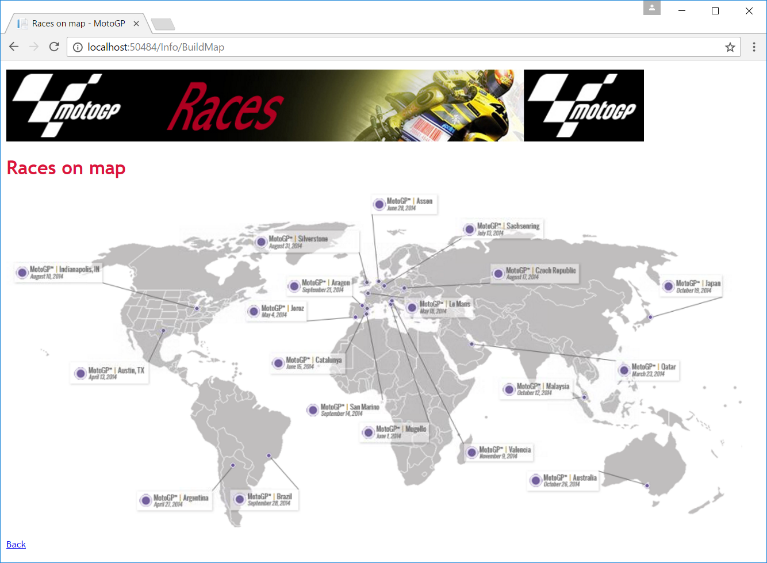

For the time being, however, this is only possible with three hard-coded races. Modify the program so you can click on all the races. **Pass the races from the controller to the view using a *View Model* instead of *ViewData*.** The detail page is not there yet, but you will make it soon.

There are still a few circles that are not clickable because there is no data about them in the database.

***2. List all races***

Now show a list of all races (you have already created the method and the view in part 1: *Info* Controller and *ListRaces* Action).

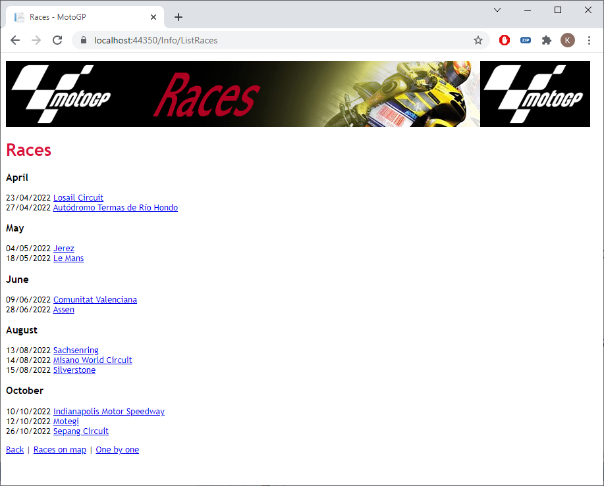

As you can see, the races appear per month in which they take place. Each race is a hyperlink to the detail (*Info/ShowRace/7*). Also note the date format!

***3. Race Details***

Now create a method *ShowRace* in the *Info* controller to view the details of a race (you must also create the view).

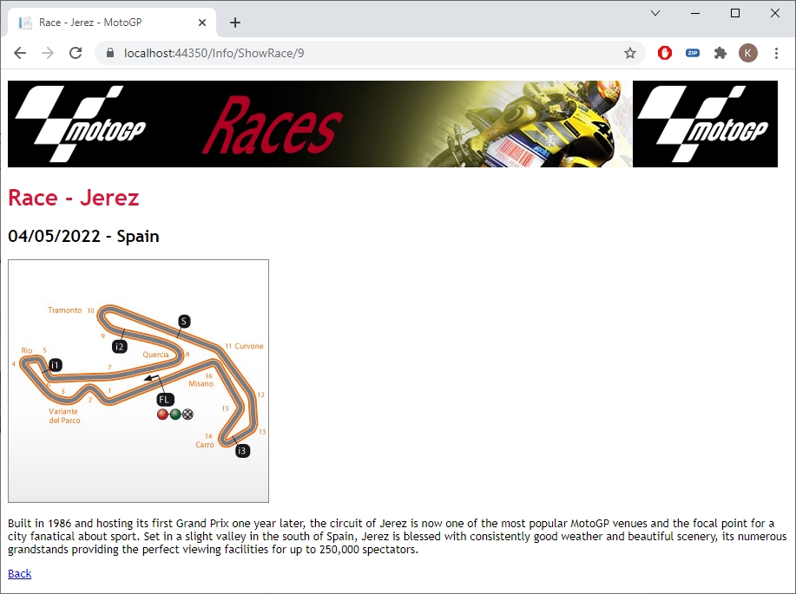

Please note the date format! Please also check that you can now view the details of the races using the map.

***4. Riders***

Now create a *ListRiders* method in the *Info* controller to show an overview of all riders (you must also create the view).

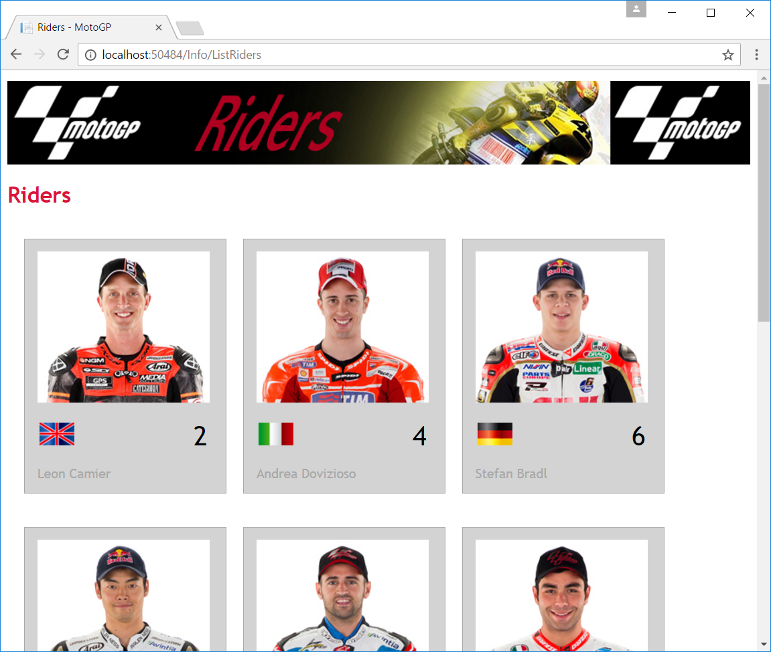

The riders are arranged by number and there are three riders per row. Also show the correct banner and title.

***5. Testing***

Take a quick test run. The menu items *Races* and *Riders* should work properly.

